LINUX COMMANDS

1. Command: Date

Syntax: date

Example: 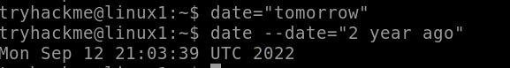

2.Command: Touch

Syntax: touch [filename]

Example:

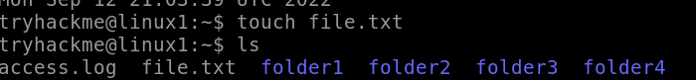

3.Command: ls

Syntax: ls

Example:

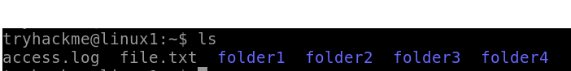

4. Command: pwd

Syntax: pwd

Example:



5. Command: cd

Syntax: cd [directory]

Example:

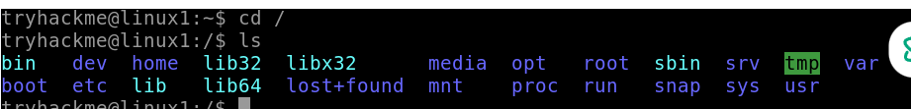

6. Command: mkdir

Syntax: mkdir [options] directory_name...

Example:

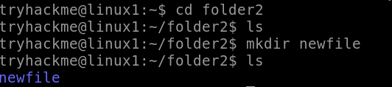

7. Command: rmkdir

Syntax: rmkdir [options] directory_name...

Example:

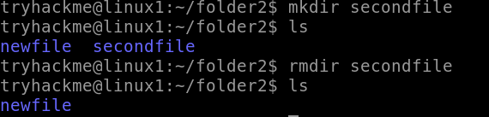

8. Command: cp

Syntax: cp [options] source... destination

Example:



9. Command: mv

Syntax: mv [options] source... newsourcename

Example:



10. Command: rm

Syntax: rm -r[directory]

Example:

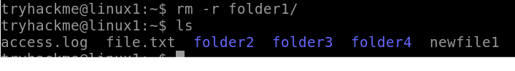

11. Command: cat

Syntax: cat >[filename]

Example:

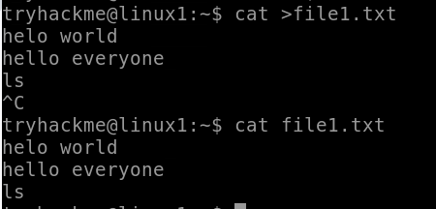

12. Command: cat -n

Syntax: cat -n[filename]

Example:

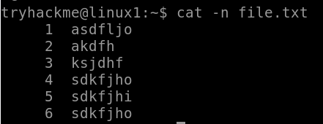

13. Command: cat >>

Syntax: cat [filename1]>>[filename2]

Example:

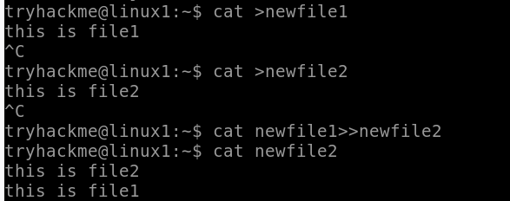

13. Command: whoami

Syntax: whoami[option]

Example: 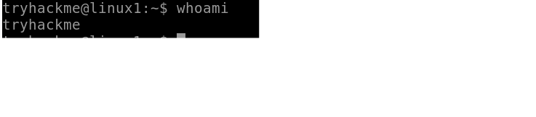

14. Command: less

Syntax: [option][filename]

Example:

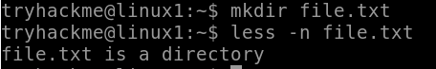

15. Command: more

Syntax: [option]<file>…

Example:

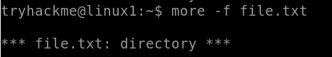

16. Command: paste

Syntax: paste [option]…[file]…

Example:

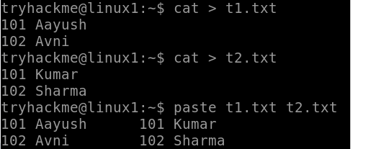

17. Command: join

Syntax: join [option]…[file]…

Example:

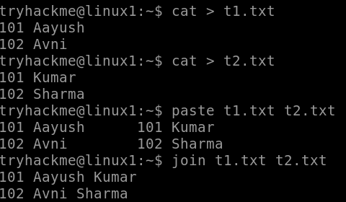

18.  Command: head   
 Syntax: head [OPTION]... [FILE]...  
 Example:

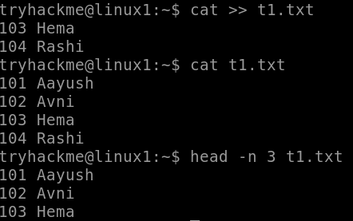

19.  Command: tail   
 Syntax: tail [OPTION]... [FILE]...  
 Example:

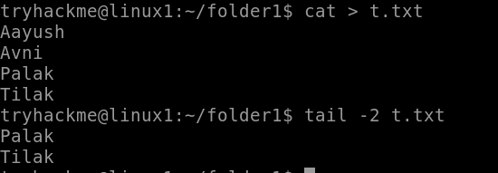

20. Command: wc   
 Syntax: wc [OPTION]... [FILE]...

Example:    
 

21. Command :  wc -l   
 Syntax: wc -l [OPTION]... [FILE]...  
 Example:



22.   Command :kill   
 Syntax: kill [signal] PID  
 Example:  kill -9 1188

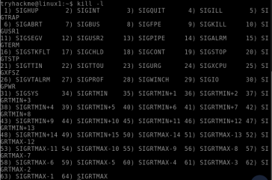

23. command-: man   
 Syntax : man [command]   
 Example: man ls

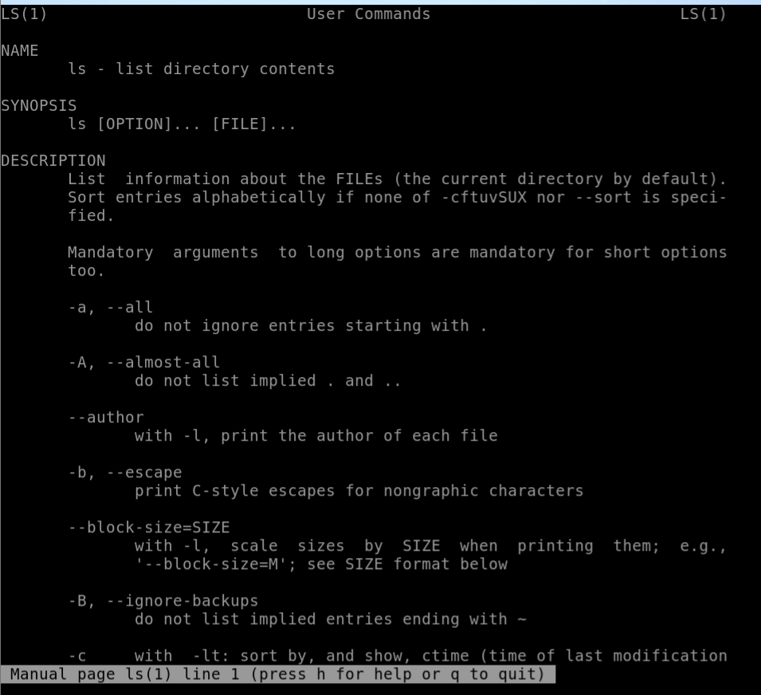

24.  command : chmod   
 Syntax: chmod [options] [mode] [File_name]  
 Example:

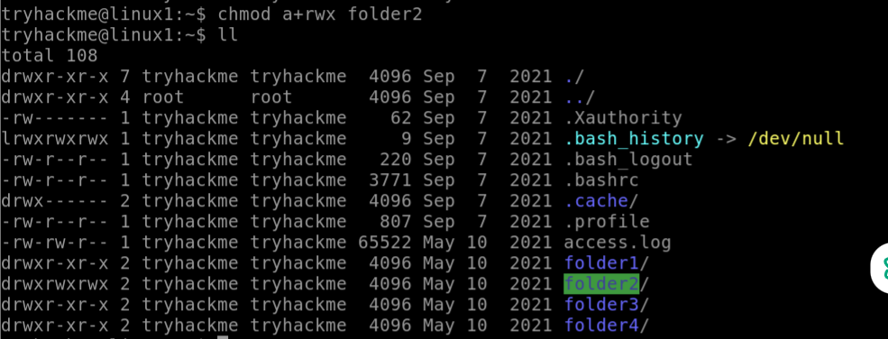

25.   Command: cal   
 Syntax: cal [ [ month ] year]  
 Example:

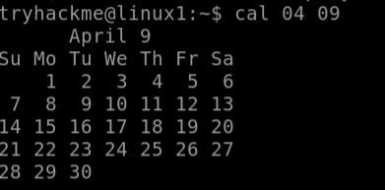

26.  Command: ifconfig   
 Syntax: ifconfig [interface] [options]  
 Example:  ifconfigcd

27.   Command: echo   
 Syntax: echo [option] [string]   
 Example:  

28.   Command: grep   
 Syntax: grep [OPTION]... PATTERNS [FILE]...  
 Example:

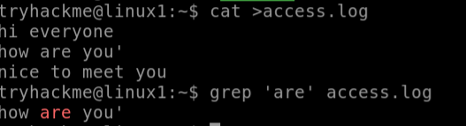

29. command: whatis   
 Syntax: whatis [command]  
 Example:



30**.**  Command: ps   
 Syntax: ps[options]  
 Example:

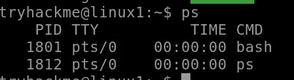

31.   command: ps   
 Syntax: ps [options]  
 Example:  ps ef

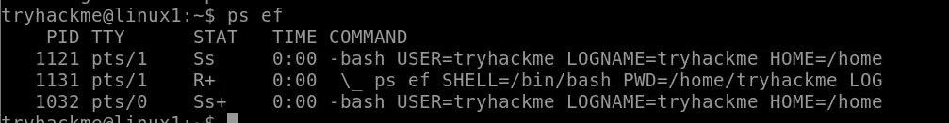

32.Command: ls -l   
 Syntax: ls [OPTION]... [FILE]...  
 Example:  ls -l text.txt

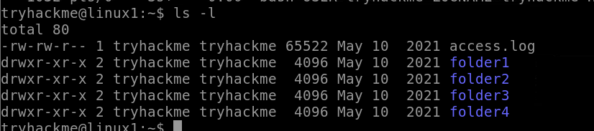

**33.**command: ls -a   
 Syntax: ls [OPTION]... [FILE]...

Example:



34.command: ls   
 Syntax: ls [OPTION]... [FILE]...  
 Example:  ls

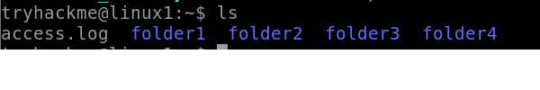

35.   command: find   
 Syntax: find [path] [options] [expression]  
 Example:

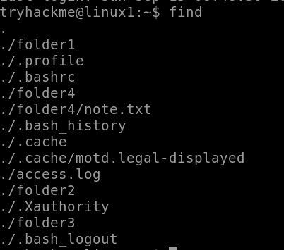

36.command: ln   
 Syntax: ln [OPTION]... [-T] TARGET LINK_NAME (1st form)   
 ln [OPTION]... TARGET... DIRECTORY (2nd form)   
 ln [OPTION]... -t DIRECTORY TARGET... (3rd form)  
 Example:  ln program.py link.py

37.   command: killall   
 Syntax: kill [signal] PID  
 Example:  killall -l

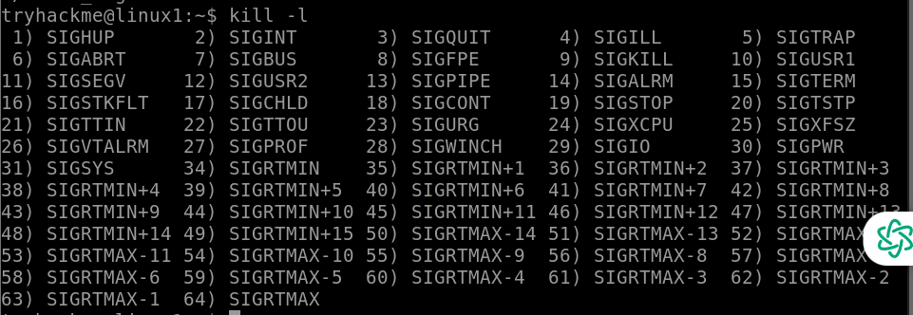

38.   command: wc   
 Syntax: wc[file]  
 Example:



39: command: ipconfig   
 Syntax: ip-a  
 Example:

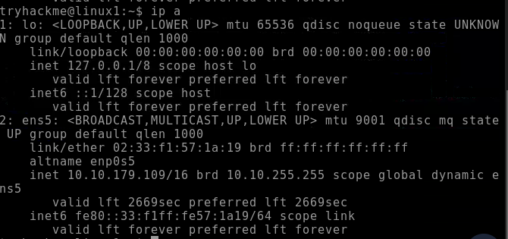

40: command: pid  
 Syntax: ps aux | grep sleep  
 Example:

